Cypress Woods High School

Computer Science Competition

December 9, 2017

General Directions (Please read carefully!):
1) DO NOT OPEN EXAM UNTIL TOLD TO DO SO.
2) No calculators of any kind may be used.
3) There are 40 questions on this contest exam. You have 45 minutes to complete this contest. If you are in the process of actually writing an answer when the signal to stop is given, you may finish writing that answer.
4) Papers may not be turned in until 45 minutes have elapsed. If you finish the test before the end of the allotted time, remain at your seat and retain your paper until told to do otherwise. You may use this time to check your answers.
5) All answers must be written on the answer sheet/Scantron card provided. Indicate your answers in the appropriate blanks provided on the answer sheet or on the Scantron card. Clean erasures are necessary for accurate Scantron grading.
6) You may place as many notations as you desire anywhere on the test paper, but not on the answer sheet or Scantron card which are reserved for answers only.
7) You may use additional scratch paper provided by the contest director.
8) All questions have ONE and only ONE correct (BEST) answer. There is a penalty for all incorrect answers. All provided code segments are intended to be syntactically correct, unless otherwise stated. Ignore any typographical errors and assume any undefined variables are defined as used.
9) A reference to commonly used Java classes is NOT provided at the end of the test, and you CANNOT use a reference sheet during the contest. There will be no reference sheets to detach from the test booklet, and do not TRY To until the contest begins.
10) Assume that any necessary import statements for standard Java packages and classes (e.g. .util, ArrayList, etc.) are included in any programs or code segments that refer to methods from these classes and packages.
11) Correct responses are based on Java JDK v8.0, from Sun Microsystems, Inc.

Scoring:

1) All questions will receive 6 points if answered correctly; no points will be given or subtracted if unanswered; 2 points will be deducted for an incorrect answer.

Cy-Woods Contest December 9, 2017
Note: Correct responses are based on Java, J2sdk v 1.8, from Sun Microsystems, Inc. All provided code segments are intended to be syntactically correct, unless otherwise stated (i. e. error is an answer choice) and any necessary Java 2 Standard Packages have been imported. Ignore any typographical errors and assume any undefined variables are defined as used. For all output statements, assume that the System class has been statically imported… import static java.lang.System.*;
Question 1 xx
What does 1010110011112 minus ABF16 equal?
A. 10₁₀ B. 10₁₆ C. 10₈ D. 10₂ E. All are equivalent
Question 2 xx  What is output by the code to the right?  A. 189 B. 116  C. 151 D. 212  E. 624 | out.println(8 * 6 - 5 + 9 * 12);
Question 3 xx  What is output by the code to the right? (* represents an empty space.)  A. Cy|***25  B. Cy-Woods|00025  C. Cy-Woods|***25  D. 2Cy-Woods|0525  E. Cy-Woods|02525252525 | String s = "Cy-Woods";  int n = 25;  out.printf("%2s|%05d", s, n);
Question 4 xx  What is output by the code to the right?  A. -1 B. 5  C. 15 D. 16  E. There is no output due to a runtime error. | String n = "Walter Han";  String m = "Nathan Huckleberry";  out.println(m.indexOf(m.charAt(16)));
Question 5 xx  What is output by the code to the right?  A. 9 B. 9.77 C. 10  D. 90 E. 232 | int x1 = 212;  int y1 = 3;  int z1 = 19;  out.println(x1+y1 / y1+z1);
Question 6 xx  What is output by the code to the right?  A. 5 B. 5.0 C. 12 D. 12.0  E. There is no output due to a runtime error. | int a = 12;  int b = 5;  out.println(Math.max(a, b));
Question 7 xx  What is output by the code to the right?  A. 0 B. 5  C. 25 D. 30  E. There is no output due to a runtime error. | int cnt = 0;  for(int i = 0; i < 5; i++){  for(int j = 0; j < 5; j++)  cnt++;  cnt++;  }  out.println(cnt);

Question 8 xx  What is output by the code to the right?  A. 1371531 B. 013715  C. 2481632 D. 25122758  E. 1251227 | int n = 1;  for(int i = 0; i < 5; i++) {  out.print(n+i);  n += n + i;  }
Question 9 xx  What values of p and q will make r equal true?  A. p = false and q = false  B. p = false and q = true  C. p = true and q = false  D. p = true and q = true  E. None of the above answers are correct. | boolean p, q;  //initialize values for p and q  boolean r = (!p ^ !q) && !(p || q);
Question 10 xx  What is output by the code to the right?  A. 2 B. 1234  C. 124 D. 234  E. 24 | int a = 10, b = 20;  if(a < 20 && a > 10)  out.print(1);  if(a >= 10 && b <= 20)  out.print(2);  else if(b > a)  out.print(3);  out.print(4);
Question 11 xx  What is output by the code to the right?  A. 7 < 212  B. 212 > 7  C. 212  D. 7Lagoon  E. There is no output due to a syntax error. | String str = "212";  String res = "7Lagoon";  if(res.length() > str.length()) out.print(str + " > " + res.length());  else  out.print(res.length() + " < " + str);
Question 12 xx  What is output by the code to the right?  A. 3.14 5.85 B. 3.14 5.14  C. 5.71 2.71 D. 5.85 2.71  E. There is no output due to a syntax error. | double x = 3.14;  double y = 2.71;  y = x + (int) y;  out.printf("%.2f %.2f",x,y);
Question 13 xx  What is output by the code to the right?  A. 0 B. 9  C. 3 D. 7  E. 10 | int total = 0;  String msg = "4 -10 12 8 -6 7 3 -1";  Scanner sc = new Scanner(msg);  while (sc.nextInt() % 2 == 1)  total += sc.nextInt();  out.println(total);

Question 14 xx  What is output by the following client code?  Penguin a = new Dogs(); out.print(a.quote());  A. See You Next Time!  B. Goodbye  C. Hello  D. Welcome!  E. There is no output due to a syntax error | interface Cats {  public abstract void cdub();  public abstract String quote();  }  class Dogs implements Cats {  public String[] arr;  public Dogs(){  arr = new String[]{  "Hello",  "Goodbye",  "See You Next Time!",  "Welcome!"  };  }  public Dogs(String abcd){  arr = new String[]{  abcd.substring(0,1),  abcd.substring(1,2),  abcd.substring(3,4),  abcd.substring(4,5)  };  }  public void cdub(){  int a = 106;  int b = 2;  out.println(a+b + " out there!");  }  public String quote(){  return arr[3] + arr[1];  }  }  class Penguin extends Dogs {  public String[] a;  public Penguin(){  a = new String[]{  "Goodbye",  "Hello",  "Welcome!",  "See You Next Time!"  };  }  public void cdub(){  out.print(a[1] + arr[1] + a[3]);  }  public String quote(){  return arr[1] + a[3] + arr[1];  }  }
Question 15 xx
What will the client code below print out?
Dogs d = new Dogs();
d.cdub();
A. 108 out there!
B. 106 out there!
C. ab out there!
D. 212 out there!
E. There is no output due to a syntax error
Question 16 xx
What is the output of the client code shown below?

Dogs p1 = new Dogs("Mr.Heath");
Penguin s1 = new Penguin();
p1.cdub(); s1.cdub();

A. 108 out there!
HelloGoodbyeSee You Next Time!
B. MrHeHelloGoodbyeSee You Next Time!
C. MrHe
HelloGoodbyeSee You Next Time!
D. There is no output due to a runtime error
E. There is no output due to a syntax error
Question 17 xx  What is output by the code to the right?  A. 0  B. []  C. null  D. There is no output due to a syntax error.  E. There is no output due to a runtime error. | ArrayList<Object> al = new ArrayList<>();  al.add(0);  al.add(null);  al.add(1,new ArrayList<Integer>());  al.add(0,"null");  al.remove(2);  out.println(al.get(0));
Question 18 xx  What is output by the code to the right?  A. 10  B. 1  C. 3  D. 6  E. There is no output due to a runtime error. | int[] k=new int[5];  for(int y=1;y<5;y++)  k[y]=k[y-1]+y;  out.println(k[3]);
Question 19 xx  What is output by the code to the right?  A. cdub\n212  \b"\n212  B. cdub  212  \b"  212  C. cdub  212  \b"\n212  D. cdub\n212\n\b"\n212  E. There is no output due to a syntax error. | String s="cdub\\n212\n\\b\"\\n212";  out.println(s);
Question 20 xx  Which of the following answer choices lists the operators on the right from most precedence to least precedence?  A. 3,1,2 B. 1,2,3  C. 2,1,3 D. 3,2,1  E. 1,3,2 | 1. ==  2. =  3. <<
Question 21 xx  What is output by the code to the right?  A. 654321 B. 132645  123456 123456  C. 123456 D. 645132  123456 123456  E. 654321  654321 | Queue<Integer> pq = new PriorityQueue<>();  Set<Integer> ts = new TreeSet<>();  for(int i = 6; i > 0; i--) {  pq.add(i); ts.add(i);  }  for(int n : pq)  out.print(n);  out.println();  for(int n : ts)  out.print(n);  out.println();
Question 22 xx  What can replace <*1> in the code on the right such that swap will properly swap the elements in the array at indices a and b?  A. arr[a] = arr[b];  arr[b] = arr[a];  B. int temp = arr[a];  arr[a] = arr[b];  arr[b] = temp;  C. arr[a] ^= arr[b];  arr[b] ^= arr[a];  D. None of the above answers can replace <*1>.  E. More than one of the above answers can replace <*1>. | public void a(int[] arr, int a, int b) {  if(a >= b) return;  a(arr,a,b-1);  c(arr,a,b);  }  public void swap(int[] arr, int a, int b) {  <*1>;  }  public void c(int[] arr, int a, int b) {  int c = b-1;  while(c >= 0 && arr[c] > arr[b]) {  swap(arr,b,c);  b--;  c--;  }  }  //client code  int[] arr = {5,3,1,0,2,4};  a(arr,0,arr.length-1);  out.println(Arrays.toString(arr));
Assume that <*1> has been filled out correctly.
Question 23 xx
What is output by the client code on the right?
A. [5,3,1,0,2,4]
B. [0,1,2,3,5,4]
C. [5,4,3,2,1,0]
D. [0,1,2,3,4,5]
E. [5,3,2,1,0,4]

Question 24 xx
What sort is implemented by methods a, swap and c?
A. Selection Sort B. Merge Sort
C. Insertion Sort D. Quick Sort
E. Radix Sort
Question 25 xx  What is output by the code to the right?  A. 212!  B. You know!  C. C-Dub  D. Academic game faces on young people  E. Hurt somebody out there | String[][] m= {{"Hurt somebody out there"},  {"Academic game faces on young people"},  {"You know!", "C-Dub", "212!"}};  String s = "";  for(int i = 0; i < m.length; i++) {  for(int j = 0; j < m[0].length; j++) {  if(m[i][j].length() > s.length())  s = m[i][j];  }  }  out.print(s);
Question 26 xx  What is returned by the call met(2,3) ?  A. 4 B. 5  C. 6 D. 7  E. 8 | public int met(int x, int y) {  if(x <= 0) return y;  return met(x-1,y) + 1;  }
Question 27 xx  What is output by the following client code?  int[] v = {2,3,6,7,9,12,64,212,300};  out.println(myst(v,212));  A. 8  B. 7  C. 6  D. 5  E. -1 | public int myst(int[] arr, int v) {  int b = 0;  int h = arr.length;  int c = 0;  while(b < h) {  int m = (b+h)/2;  if(arr[m] <= v)  b = m+1;  else  h = m;  c++;  }  if(b == 0 || arr[b-1] != v) return -1;  return b-1;  }
Question 28 xx
What algorithm is implemented by method myst() to the right?
A. Sequential Search
B. Binary Search
C. Split Search
D. Radix Search
E. Kayak Search

Question 29 xx  What is the BigO runtime of the code to the right? Assume N has been initialized to a positive number.  A. O(N⁴) B. O(N) C. O(N²)  D. O(NlogN) E. O(logN) | int x = 0;  for(int i = 0; i < N; i++) {  x++;  for(int j = 0; j < 10; j++) x++;  }
Question 30 xx  What is output by the code to the right?  A. 14  B. 128  C. 198  D. 199  E. 212 | out.println(1 << 1 & 7 | 212 ^ 18);
Question 31 xx  What is returned by the call gamma()?  A. 8  B. 24  C. 36  D. 54  E. 212 | public int alpha(int a, int b) {  int s = beta(a);  int t = beta(b);  return beta((s+t)/2);  }  public int beta(int n) {  if(n == 0) return 0;  return n + beta(n-1);  }  public int gamma() {  return alpha(3,4);  }
Question 32 xx  Which values of A, B, C, and D respectively will make E equal true? (1 = true and 0 = false)  A B C D  A. 1 1 0 0  B. 0 0 1 1  C. 1 0 1 1  D. 0 1 0 0  E. 1 0 0 0 | 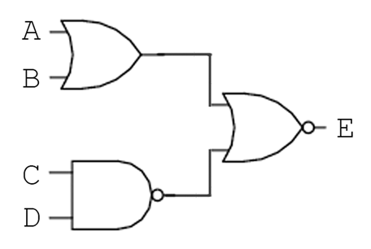

Question 33 xx  Which adjacency matrix represents the graph shown on the right?  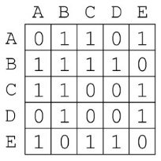  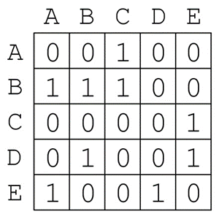  A. B.  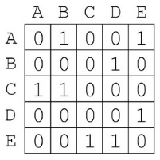  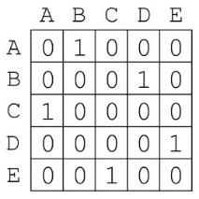  C. D.  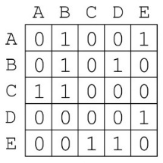  E. | 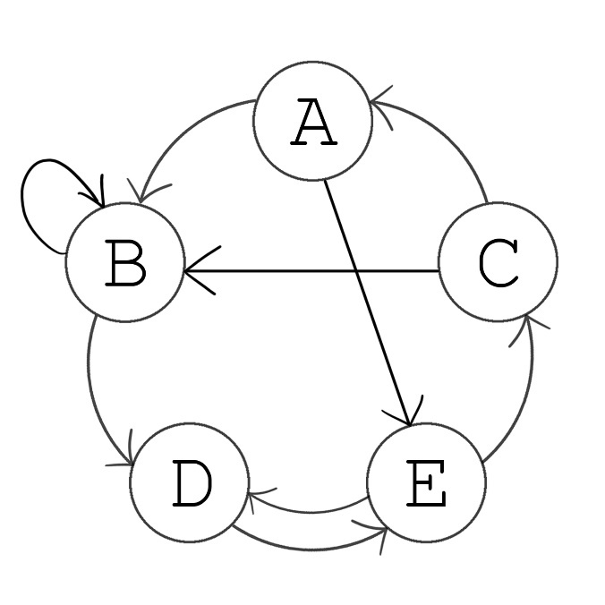  -
Question 34 xx
What kind of graph is the graph to the right?
A. Directed B. Weighted
C. Connected D. A and B
E. A and C

Question 35 xx  What is output by the code to the right?  A. falsefalse B. truefalse  C. falsetrue D. truetrue  E. There is no output due to a syntax error. | String s1 = "Wildcats 212!";  String s2 = "Tamebats 313?";  String regex = "[A-Za-z]+ \\d+\\?";  out.print(s1.matches(regex));  out.print(s2.matches(regex));
Question 36 xx  What is output by the client code below?  Structure s = new Structure(10);  int[] data = {5,3,9,212,7,6};  for(int i = 0; i < data.length; i++)  s.add(data[i]);  s.remove();  s.remove();  out.println(s.remove());  out.println(s);  A. 9  [212,7,6]  B. 7  [5,3,6]  C. 6  [7,212,9]  D. 7  [6,5,3]  E. 6  [7,9,212] | class Structure {  int[] arr;  int size;  public Structure(int s) {  arr = new int[s];  size = 1;  }  public void add(int value) {  arr[size] = value;  size++;  up();  }  public int remove() {  int result = arr[1];  size--;  arr[1] = arr[size];  down();  return result;  }  public void up() {  int i = size-1;  while(i > 1) {  int p = i/2;  if(arr[p] > arr[i]) {  met(i,p);  } else {  break;  }  i = p;  }  }  public void down() {  int i = 1;  while(i < size) {  int l = 2*i;  int r = 2*i+1;  if(r < size && arr[r] < arr[l] &&  arr[r] < arr[i]) {  met(i,r);  i = r;  } else if(l < size && arr[l] < arr[i]) {  met(i,l);  i = l;  }  else {  break;  }  }  }  public void met(int i, int j) {  int t = arr[i];  arr[i] = arr[j];  arr[j] = t;  }  public String toString() {  String s = "[";  for(int i = 1; i < size; i++) {  s = s + arr[i] + ",";  }  return s.substring(0, s.length()-1) + "]";  }  }
Question 37 xx
Given that array arr contains N integers, what is the worst case order (Big O) of the up() method in the Structure class? Assume the met() method is O(1). Choose the most restrictive correct answer.

A. O(logN)
B. O(N)
C. O(NlogN)
D. O(N²)
E. O(N!)
Question 38 xx
What kind of data structure does Structure implement?
A. Binary Search Tree
B. Heap
C. Linked List
D. Stack
E. Radix Tree

Question 39 xx  OPEN ENDED QUESTION – Write a simplified, Boolean expression that is equivalent to the expression on the right. Your answer should include as few logical operators as possible. | (($\overline{A}$$\overline{B}$)*($\overline{B}$* C)+C)*A
Question 40 xx
OPEN ENDED QUESTION – What is the answer to the arithmetic expression below? The expression is in reverse Polish notation.

4 2 16 2 / 3 – 5 * * 3 + *

